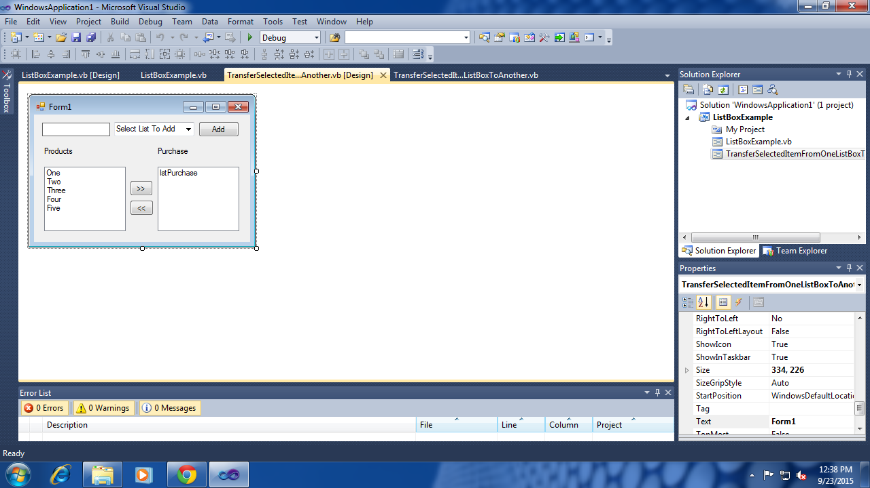

Public Class TransferSelectedItemFromOneListBoxToAnother

Private Sub Button1_Click(ByVal sender As System.Object, ByVal e As System.EventArgs) Handles btnMoveRight.Click

If lstProduct.Items.Count > 0 And lstProduct.SelectedIndex >= 0 Then

lstPurchase.Items.Add(lstProduct.SelectedItem)

'ListBox1.Items.RemoveAt(ListBox1.SelectedIndex)

lstProduct.Items.Remove(lstProduct.SelectedItem)

Else

MsgBox("Product List is empty or you have not selected an item ", MsgBoxStyle.Information, "My Message Box")

End If

End Sub

Private Sub Button2_Click(ByVal sender As System.Object, ByVal e As System.EventArgs) Handles btnMoveLeft.Click

If lstPurchase.Items.Count > 0 Then

lstProduct.Items.Add(lstPurchase.SelectedItem)

lstPurchase.Items.RemoveAt(lstPurchase.SelectedIndex)

' ListBox2.Items.Remove(ListBox2.SelectedItem)

Else

MsgBox("Purchase List is empty or you have not selected an item ", MsgBoxStyle.Information, "My Message Box")

End If

End Sub

Private Sub Button3_Click(ByVal sender As System.Object, ByVal e As System.EventArgs) Handles btnAdd.Click

If cbSelect.SelectedIndex >= 0 Then

Dim selection As Byte = cbSelect.SelectedIndex

Select Case selection

Case 0

lstProduct.Items.Add(txtAdd.Text)

Case 1

lstPurchase.Items.Add(txtAdd.Text)

End Select

txtAdd.Text = ""

txtAdd.Select()

Else

MsgBox("Please select one list box name", MsgBoxStyle.Exclamation, "Error!!")

End If

End Sub

Private Sub lstProduct_SelectedIndexChanged(ByVal sender As System.Object, ByVal e As System.EventArgs) Handles lstProduct.SelectedIndexChanged

End Sub

End Class

<Global.Microsoft.VisualBasic.CompilerServices.DesignerGenerated()> _

Partial Class TransferSelectedItemFromOneListBoxToAnother

Inherits System.Windows.Forms.Form

'Form overrides dispose to clean up the component list.

<System.Diagnostics.DebuggerNonUserCode()> _

Protected Overrides Sub Dispose(ByVal disposing As Boolean)

Try

If disposing AndAlso components IsNot Nothing Then

components.Dispose()

End If

Finally

MyBase.Dispose(disposing)

End Try

End Sub

'Required by the Windows Form Designer

Private components As System.ComponentModel.IContainer

'NOTE: The following procedure is required by the Windows Form Designer

'It can be modified using the Windows Form Designer.

'Do not modify it using the code editor.

<System.Diagnostics.DebuggerStepThrough()> _

Private Sub InitializeComponent()

Me.lstProduct = New System.Windows.Forms.ListBox()

Me.lstPurchase = New System.Windows.Forms.ListBox()

Me.btnMoveRight = New System.Windows.Forms.Button()

Me.btnMoveLeft = New System.Windows.Forms.Button()

Me.btnAdd = New System.Windows.Forms.Button()

Me.Label1 = New System.Windows.Forms.Label()

Me.Label2 = New System.Windows.Forms.Label()

Me.txtAdd = New System.Windows.Forms.TextBox()

Me.cbSelect = New System.Windows.Forms.ComboBox()

Me.SuspendLayout()

'

'lstProduct

'

Me.lstProduct.FormattingEnabled = True

Me.lstProduct.Items.AddRange(New Object() {"One", "Two", "Three", "Four", "Five"})

Me.lstProduct.Location = New System.Drawing.Point(15, 77)

Me.lstProduct.Name = "lstProduct"

Me.lstProduct.Size = New System.Drawing.Size(120, 95)

Me.lstProduct.TabIndex = 0

'

'lstPurchase

'

Me.lstPurchase.FormattingEnabled = True

Me.lstPurchase.Location = New System.Drawing.Point(182, 77)

Me.lstPurchase.Name = "lstPurchase"

Me.lstPurchase.Size = New System.Drawing.Size(120, 95)

Me.lstPurchase.TabIndex = 1

'

'btnMoveRight

'

Me.btnMoveRight.Location = New System.Drawing.Point(141, 97)

Me.btnMoveRight.Name = "btnMoveRight"

Me.btnMoveRight.Size = New System.Drawing.Size(34, 23)

Me.btnMoveRight.TabIndex = 2

Me.btnMoveRight.Text = ">>"

Me.btnMoveRight.UseVisualStyleBackColor = True

'

'btnMoveLeft

'

Me.btnMoveLeft.Location = New System.Drawing.Point(141, 126)

Me.btnMoveLeft.Name = "btnMoveLeft"

Me.btnMoveLeft.Size = New System.Drawing.Size(35, 23)

Me.btnMoveLeft.TabIndex = 3

Me.btnMoveLeft.Text = "<<"

Me.btnMoveLeft.UseVisualStyleBackColor = True

'

'btnAdd

'

Me.btnAdd.Location = New System.Drawing.Point(242, 10)

Me.btnAdd.Name = "btnAdd"

Me.btnAdd.Size = New System.Drawing.Size(60, 23)

Me.btnAdd.TabIndex = 4

Me.btnAdd.Text = "Add"

Me.btnAdd.UseVisualStyleBackColor = True

'

'Label1

'

Me.Label1.AutoSize = True

Me.Label1.Location = New System.Drawing.Point(12, 47)

Me.Label1.Name = "Label1"

Me.Label1.Size = New System.Drawing.Size(49, 13)

Me.Label1.TabIndex = 7

Me.Label1.Text = "Products"

'

'Label2

'

Me.Label2.AutoSize = True

Me.Label2.Location = New System.Drawing.Point(179, 47)

Me.Label2.Name = "Label2"

Me.Label2.Size = New System.Drawing.Size(52, 13)

Me.Label2.TabIndex = 8

Me.Label2.Text = "Purchase"

'

'txtAdd

'

Me.txtAdd.BorderStyle = System.Windows.Forms.BorderStyle.FixedSingle

Me.txtAdd.Location = New System.Drawing.Point(12, 12)

Me.txtAdd.Name = "txtAdd"

Me.txtAdd.Size = New System.Drawing.Size(100, 20)

Me.txtAdd.TabIndex = 9

'

'cbSelect

'

Me.cbSelect.FormattingEnabled = True

Me.cbSelect.Items.AddRange(New Object() {"Products List", "Purchase List"})

Me.cbSelect.Location = New System.Drawing.Point(118, 11)

Me.cbSelect.Name = "cbSelect"

Me.cbSelect.Size = New System.Drawing.Size(118, 21)

Me.cbSelect.TabIndex = 10

Me.cbSelect.Text = "Select List To Add"

'

'TransferSelectedItemFromOneListBoxToAnother

'

Me.AutoScaleDimensions = New System.Drawing.SizeF(6.0!, 13.0!)

Me.AutoScaleMode = System.Windows.Forms.AutoScaleMode.Font

Me.ClientSize = New System.Drawing.Size(318, 188)

Me.Controls.Add(Me.cbSelect)

Me.Controls.Add(Me.txtAdd)

Me.Controls.Add(Me.Label2)

Me.Controls.Add(Me.Label1)

Me.Controls.Add(Me.btnAdd)

Me.Controls.Add(Me.btnMoveLeft)

Me.Controls.Add(Me.btnMoveRight)

Me.Controls.Add(Me.lstPurchase)

Me.Controls.Add(Me.lstProduct)

Me.Name = "TransferSelectedItemFromOneListBoxToAnother"

Me.Text = "Form1"

Me.ResumeLayout(False)

Me.PerformLayout()

End Sub

Friend WithEvents lstProduct As System.Windows.Forms.ListBox

Friend WithEvents lstPurchase As System.Windows.Forms.ListBox

Friend WithEvents btnMoveRight As System.Windows.Forms.Button

Friend WithEvents btnMoveLeft As System.Windows.Forms.Button

Friend WithEvents btnAdd As System.Windows.Forms.Button

Friend WithEvents Label1 As System.Windows.Forms.Label

Friend WithEvents Label2 As System.Windows.Forms.Label

Friend WithEvents txtAdd As System.Windows.Forms.TextBox

Friend WithEvents cbSelect As System.Windows.Forms.ComboBox

End Class